**Mr. Montante**

**8th grade Social Studies Packet**

**Questions can be answered via email:** [**mmontante@nfschools.net**](mailto:mmontante@nfschools.net)

**Also you can join my Remind at the following website:** <https://www.remind.com/join/mrmontante>

**If technology is available at a later date you can do the same assignment online. I have detailed instructions on my webpage on the Gaskill website.**

**To complete this packet answer all questions in complete sentences. Please note any special directions on pages inside the packet.**

**Packet Objectives:**

* **Students can explain the causes of WWII.**
* **Students can explain U.S. neutrality at the beginning of WWII and the shift towards supporting the Allies**
* **Students can explain why the U.S. became involved in the war.**
* **Students can analyze the impact the War had on day to day life.**

**Directions:** Answer all questions in complete sentences. Remember to use the R.A.C.E. strategy.

**Global Depression in Germany**

When the stock market collapsed on Wall Street on Tuesday, October 29, 1929, it sent financial markets worldwide into a tailspin with disastrous effects.

The German economy was especially vulnerable since it was built upon foreign capital, mostly loans from America and was very dependent on foreign trade. When those loans suddenly came due and when the world market for German exports dried up, the well-oiled German industrial machine quickly ground to a halt.

1. Why did America’s stock market collapse impact Germany so much?

As production levels fell, German workers were laid off. Along with this, banks failed throughout Germany. Savings accounts, the result of years of hard work, were instantly wiped out. Inflation soon followed making it hard for families to purchase expensive necessities with devalued money.

Overnight, the middle class standard of living so many German families enjoyed was ruined by events outside of Germany, beyond their control. The Great Depression began and they were cast into poverty and deep misery and began looking for a solution, any solution.

1. Compare & Contrast: How did the conditions in Germany during the depression compare to the conditions in America?

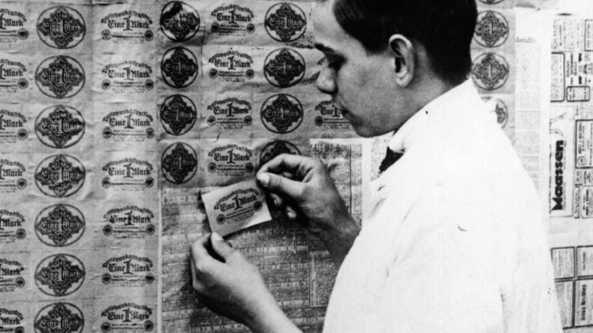Nobody in America, Germany, Britain, or anywhere on Earth had a real answer to fix the depression. President Roosevelt tried things like the New Deal to fix it but that was like using a normal bandage on a deep 8 inch cut. Sure it’s giving some relief but that cut needs stitches. Germany tried to print more money but that just made prices climb through the roof! Stories of Germans filling wheelbarrows full of paper money and taking it to the store to get breads and milk are told when discussing the depression in Germany. There are even stories of Germans burning money for eat or using it for wall paper because it was so worthless. It seemed that nobody could figure this out until one person came along.

1. Were attempts to fix the economy working in Germany? Explain why or why not.

A new man came into power in Germany, his name was Adolf Hitler and he was part of the National Socialist German Workers' Party, or as they are commonly known as Nazis. Hitler fought for Germany in WWI. If you remember how that War ends, Germany is forced to take blame for it all and pay for it. The 1920s were not fun in Germany like they were in America. Hitler wanted to take control of Germany as early as 1923. He thought Germany should not be suffering because of World War I and forced to pay for it all because German people were experiencing their own money troubles. His first attempt to become leader was a failed overthrowing of the government. This landed him in jail.

1. Why might Hitler having been mad and wanted to rule Germany?

In jail, Hitler wrote a book that was really the building block for his plan to take control of Germany. This time he decided to play by the rules. Once he was out of jail, Hitler reformed his approach. He needed to appeal to the masses of Germany to win an election. He was able to successfully do it. He promised to return Germany to power and glory, the way there were before WWI. His promises were things like restoring the military, getting new territories Hitler believed to be rightfully Germany’s and restoring industry by making weapons and military supplies (they were not allowed to do this stuff based on the treaty that ended WWI). He would put people back to work in factories making this stuff. He also was able to create an enemy within German borders to really unite most German citizens. He blamed the economic troubles on the Jewish people.

1. What is Hitler’s plan to help Germany?
2. Imagine you were a poor German person burning money to keep warm, would you like his plans that make Germany a power place, and puts you back to work?

Why did he blame Jewish people? There are many things that go into this plan. Historically Jewish people were not liked in Europe. In addition, Jewish people were educated and with that came good paying jobs that survived even during depressions. Jews were commonly lawyers, doctors, or even ran their own business. While many Germans were hungry, unemployed, and homeless, Jewish people stilled had jobs and homes. Hitler hated Jews because of this along with his own personal hate, but he knew he could push all the blame on them giving way for him to get power.

1. Why did Hitler blame the Jews? Why did people believe him?

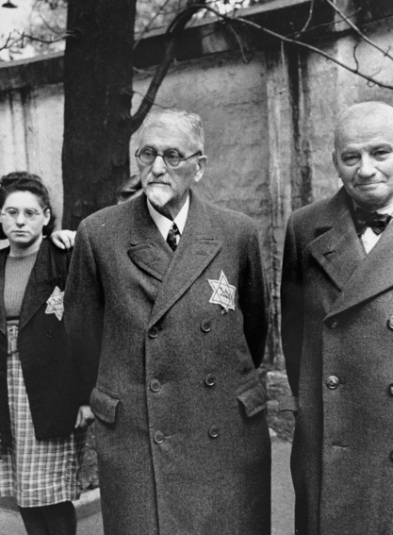Hitler and the Nazi party won the elections of 1933. They instantly started making good on their promises of industry and military. Germany was fighting the depression and maybe winning but it’s because they were preparing a war and evil deeds to be carried out. As much economic good Hitler was doing he was doing socially bad stuff. If you opposed Hitler opening you could be in jail or worse, have a nighttime visit from his own private police (the S.S.) where you would just disappear. The reality is you were either killed or sent to work in concentration camp. It was through this fear, Hitler controlled the news and education. He would shape the news in education to convince German citizens, “Germans are the greatest people, Hitler is the best, and Jews are bad”. It was because of this change in reporting information and education he was able to do very nasty things to the Jews. Hitler started small by making Jews wear a Star of David on their clothes so people knew you were Jewish. Next, he started forcing them to live in bad parts of cities and towns called the ghetto. Hitler would go on to much worse things but will continue that sad story later.

1. What was one way Hitler tried to control society?

**GO TO THE NEXT PAGE**

**World War II: Causes (1919–1939)**

**Causes of World War II**

The death and destruction of World War I was so horrible that it was called “the war to end all wars.” Yet, the agreement to end World War I did not resolve the problems of the world and, according to some historians, lead directly to the next **catastrophe**: World War II. The major causes of World War II were numerous. They include the impact of the Treaty of Versailles following WWI, the worldwide economic depression, failure of appeasement, the rise of militarism in Germany and Japan, and the failure of the League of Nations

**Treaty of Versailles**

Following World War I, the victorious Allied Powers met to decide Germany’s future. Germany would be forced to sign the Treaty of Versailles. Germany had to accept guilt for the war and to pay **reparations**. Germany lost territory and was prohibited from having a large military.

1. Who had to accept blame for WWI? What did they have to do as a result of that?

**Economic Depression**

The whole world was hit by an economic depression in the late 1920s. In a depression, economies shrink, trade is reduced, businesses close, prices fall, banks fail, and unemployment rises. Sometimes during a depression, people look for a strong political leader to resolve their problems. In 1933, Adolf Hitler became the leader of Germany by promising to restore German wealth and power.

1. How did Hitler take advantage of the Economic Depression?

**Germany’s Militarism**

Hitler immediately began secretly building up Germany’s army and weapons. Although Britain and France knew of Hitler’s actions, they thought a stronger Germany would stop the spread of Communism from Russia. In 1936 Hitler ordered German troops to enter the German-speaking areas of the Rhineland (France), Austria, and Czechoslovakia. At this point neither France nor Britain was prepared to go to war. In 1936, Hitler made **alliance**s with Italy and Japan. The military alliance of Germany, Italy, and Japan was called the Axis Powers.

1. Summarize what Germany’s new Militarism was.

**Failure of Appeasement**

**Appeasement** meant agreeing to the demands of another nation in order to avoid conflict. This belief, adopted by Britain, was the Policy of Appeasement. An example of appeasement was the Munich Agreement of September 1938. In the Agreement, Britain and France allowed Germany to **annex** areas in Czechoslovakia where German-speakers lived. Germany agreed not to invade the rest of Czechoslovakia or any other country. Each time Britain and France appeased Hitler it actually gave Hitler more power because he was getting what he wanted (imagine being punished and then 5 minutes later being allowed to have your phone back). In March 1939, Germany broke its promise and invaded the rest of Czechoslovakia. Neither Britain nor France was prepared to take military action. Then, on September 1, 1939, German troops invaded Poland. Britain and France immediately declared war on Germany. World War II had begun in Europe.

1. What is Appeasement?
2. Did Appeasement work with Hitler? Explain why or why not (what ended up happening anyway?)

**Failure of the League of Nations**

The League of Nations was an international organization set up in 1919 to keep world peace. It was intended that all countries would be members and that if there were disputes between countries, they could be settled by negotiation rather than by force. The League of Nations was a good idea, but ultimately a failure. Not all countries joined the league and the League had no army to prevent military aggression such as Italy’s invasion of Ethiopia in Africa or Japan’s invasion of Manchuria in China.

1. Why did the League of Nations fail?

**Japan’s Militarism**

In 1931, Japan was hit badly by the economic depression. Japanese people lost faith in the government. They turned to the army in order to find a solution to their economic problems. In order to produce more goods, Japan needed **natural resources** for its factories. Japan is a series of islands that are very rocky and filled with mountains so they lacked these resources or factories. As a result, the Japanese army invaded China, an area rich in minerals and resources. China asked for help from the League of Nations. Japan ignored the League of Nations and continued to occupy China and Korea. As Japan invaded other areas of South East Asia including Vietnam, the United States grew concerned about its territories in Asia, such as the Philippines and Guam. Japan joined a military alliance with Nazi German.

1. Why did Japan build an empire? (Why did they need access to foreign land?)

Key Vocabulary

**Appeasement**: giving in to another country’s demands often in an effort to prevent war or other problems

**Alliance**: agreement between nations; often one nation agrees to defend another nation in time of war

**Catastrophe**: an event causing great and often sudden damage or suffering; a disaster

**Reparations**: payments for damages that occur during a war, usually paid by the losing side

**Annex**: to add or attach especially to something larger, sometimes done without permission

**Natural resources**: materials such as minerals, oil, or wood that come directly from nature and are used in the manufacturing process

**Militarism**: the belief that a country should maintain a strong military and be prepared to use it aggressively to defend or promote national interests

**END OF 4/27 to 5/1 WORK. GO TO NEXT PAGE!**

**Directions**: Answer questions in complete sentences. Use the R.A.C.E strategy.

**World War II**

**The beginning**

World War II’s official beginning is September 1, 1939 but, it was building for a long time. Germany was placed with all the blame and forced to pay for the damages of World War I. This gave way for Hitler to become elected leader in Germany. He promised to not just make Germany better on the inside but he planned to expand and take over lands they used to rule. The leaders of Britain and France were so desperate to avoid war with Germany because the countries still have not recovered from the First World War.

Britain and France thought they could appease Hitler, or let him get what he wanted in the efforts to avoid a war. Britain and France let Hitler take over lands the border France, Austria, and Czechoslovakia. Germany made alliances with Italy and Japan and they would be known as the Axis Powers. Germany was setting their sights on Poland next. They made a non-aggressor pact with the Soviet Union (Russia). They agreed not to attack each other and split up Poland. Britain and France knew they had to take a stand or Hitler would become too powerful. Britain and France formed an alliances called the Allied Powers. Hitler invaded Poland on September 1, 1939. The Allied Powers declared war on Germany and its allies (Italy since they were in Europe).

1. Did Britain and France’s plan of appeasement work with Germany? Explain.

|  |
| --- |
| Europe in 1941 |

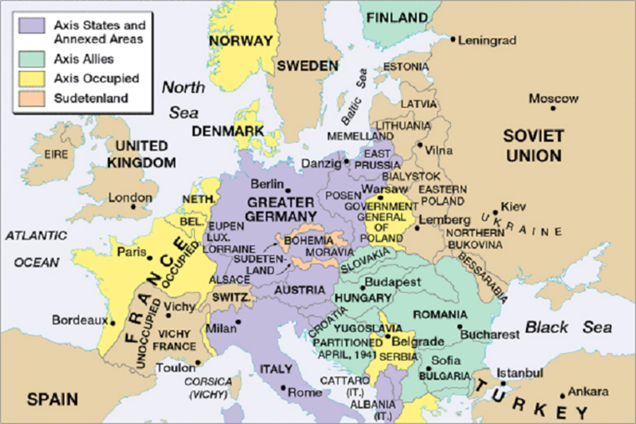In the beginning of the war Germany dominates the fighting. They made quick work of Poland using a strategy called Blitzkrieg. They would strike hard and fast. Think of it like a blitz in football. They used planes and new faster tanks to win battles. They took over most of Northern Europe by 1940. Next they turned their attention to Western Europe. They quickly invaded and defeated France. Hitler basically puts governments he can control in power in France. Germany’s only foe remaining was Britain.

1. Who was winning the war early on?

Britain (United Kingdom as it is labeled on the map) was an island nation. They had a very strong navy so Germany was never able to launch an invasion on Britain. Instead they relied on numerous airstrikes on cities. In an air battle pitting Britain’s air force vs Nazi Germany’s air force, Britain comes out victorious in the battle of Britain. Thanks to this win Nazi advancement halts towards the west.

1. Who wins the air battles over Britain? Why is this an important victory?

With efforts stalled in the west, Hitler had a new plan and probably his biggest mistake. He decided to launch an Eastern campaign on the Soviet Union (Russia). Russia may not have been the best equipped (old or outdated planes) to fight the Nazis but they were many, proud, and tactical. As the battles went on the Nazis were winning and getting deeper into Russia. The Nazis found themselves deep in Russia during the cold winter cut off from supplies. Soviet and Nazi troops met in a major battle at Stalingrad. It lasted over 5 months and it was Soviet victory. This ultimately stopped German advances into Russia. Now they would have to play a defensive game.

1. Who won the Battle of Stalingrad?
2. Why was this battle so important?

What was the United States doing during all of this? Well they were staying out of it and minding their own business. Well they sort of were. The United States official stance was **Neutrality** or not picking a side. The United States clearly did not want to get involved in another European war but as the war became more serious and Nazis were gaining more victories the US decided to help their find Britain. The help wasn’t with troops but instead military supplies. The United States made agreements to send old ships and other weapons and supplies to Britain in exchange for access to military bases. This was called the Lend-Lease Act. They had to do these types of trades because Britain was broke from fighting this war.

1. What was the United States doing to help the British?

Some people thought Lend-Lease Act wasn’t enough and that America should be over there fighting for freedom against the Nazis too. Famous children’s writer Dr. Suess made political cartoons criticizing the U.S. states for minding their own business and even said that Britain’s problem will eventually become theirs.

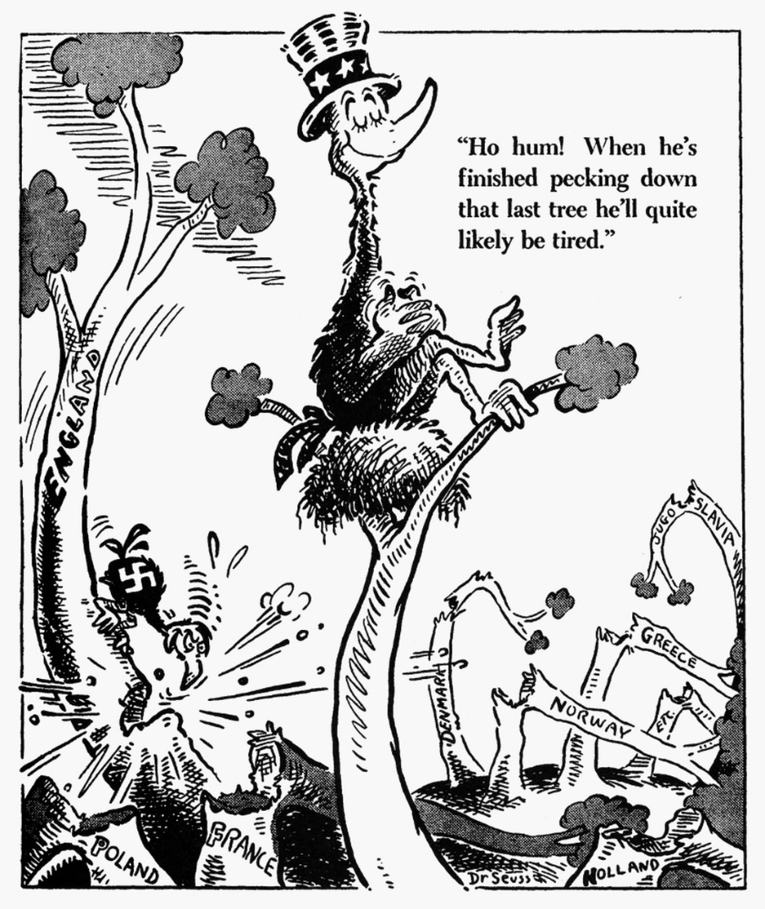

1. Who or what does the wood pecker represent?
2. What do the trees represent?
3. According to the cartoon, should the American bird be worried?

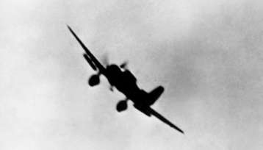**Pearl Harbor**

The Attack on Pearl Harbor happened on December 7th, 1941. Japanese airplanes made a surprise attack on the US Navy in Pearl Harbor. They destroyed many ships and killed many soldiers. It was this attack that forced the United States to enter World War II.   
  
Where is Pearl Harbor?

Pearl Harbor is located in Hawaii on the island of O'ahu. Hawaii is located in the Pacific Ocean between California and Japan. During the time of World War II, Hawaii was not a state, but a US territory.

Before the Attack

World War II had been raging in Europe and Asia for two years, but the United States had not entered the war. The Empire of Japan was trying to take over much of Asia and was worried about the US Navy in Hawaii. They decided to strike in order to prevent the United States from attacking them. The Japanese thought that if they took out the war ships in Pearl Harbor, then the United States Navy would be crippled and would never attack. However, they were mistaken and the attack on Pearl Harbor had just the opposite result. The US declared war the next day.

1. Why was Japan worried about the United States?

The Attack

The attack on Pearl Harbor came as a complete surprise. Hundreds of Japanese fighter planes and bombers flew to Pearl Harbor and attacked. The bombers dropped bombs and torpedoes on the war ships, while the fighter planes attacked the US fighter planes on the ground so they could not take off and fight back. There were two waves of attacks and by the end of the second wave a number of US ships were destroyed.

1. What made Pearl Harbor a successful attack?

After the Attack

The citizens of the United States were in shock. They had tried to avoid the war, but they could not ignore this attack. The Japanese had hoped to break the Americans by attacking Pearl Harbor, instead they united them. The next day, December 8th, 1941, the US declared war on Japan. Three days later Japan's allies, Germany and Italy, declared war on the United States. The United States was now a major part of World War II.

The US Navy was able to recover from the attack on Pearl Harbor fairly quickly. The Japanese had not damaged a number of important facilities on the Hawaiian Islands, including oil storage depots and repair yards. Also, no aircraft carriers were in Pearl Harbor at the time of the attack. Aircraft carriers would soon become the most important type of navy vessels in the war.

1. What happened as a result of the attacks on Pearl Harbor? What did the United States do?

The Following is a link to actual footage from pearl harbor. Please watch to see first hand what made the United States declare war on Japan.

<https://www.youtube.com/watch?v=WvhJboFYFX4>

**GO TO THE NEXT PAGE**

**Japanese Internment**

Historical Context: After Pearl Harbor American were shocked and afraid. Fear can make people think irrationally and it happened in America in WWII. People were afraid that Japanese Americans, even those who were born in the United States were spies. As a result the U.S. government rounded up Japanese Americans and put them in places called Internment camp. It was nothing like the concentration camps you may have heard of and we will learn about but it still was not pleasant especially since these people had their right taken away. You will read an account from people that were taken to these camps.

My name is **Reiko Oshima Komoto**. I was born in **San Lorenzo, California** in 1932.

Regarding my internment years, it was not a good experience.

The **family** consisted of Father, Mother, four boys, and three girls; and we lived in **Oakland, California**. Father and Mother were residents of California for twenty-one years at the time. Most of the children were attending school when the order to relocate all Japanese Americans from the West Coast was issued on March 1942. We were sent to **Tanforan Race Track**(an assembly center) in **San Bruno, California** with only what we could carry in clothing and personal possessions. All radios and cameras were confiscated. Furniture and household goods were stored in our next door neighbor's basement and never retrieved.

Our **sleeping quarters** consisted of two white washed horse stalls. All bathrooms, dining hall, and similar rooms were located in other buildings. School was held in the dining room with all grades and dining tables in place of desks.

Topaz consisted of blocks; how many I don't recall, but the total number of people was approximately 8,300. Each block contained two rows of eight, tar-papered barracks, one-story, twenty by one hundred feet. An H-shaped building in the middle of the block that contained a laundry room, separate bathrooms for males and females. All **shower and toilet**stalls were without doors or curtains. Each block also had a separate building for meals. I remember waiting in line to receive our **food** and lots of organ meats (kidney, liver and heart) being served. Food on the most part was not good depending on the cook's culinary skills and groceries allotted. Our sleeping quarters consisted of two large rooms (approximately 20' x 25'); metal cots, and army blankets. There was a pot bellied stove for heating. I saw snow for the first time but don't remember it collecting on the ground for any length of time. I remember sand covering the room after storms (resembling miniature tornadoes).

One **barrack** for the whole camp was used as a store; another as a movie theater, and one as a library. The library was quite a distance from our block, but walking was the only alternative since cars were not allowed. The neighbor across the street somehow managed to make a pool with local fish swimming in it. How he obtained the cement and fish, I have no clue. Somehow I acquired a horned toad as a pet. I don't believe **pets** were allowed, though an elderly man was shot trying to retrieve his dog that got too close to the fence.

In the beginning, **guards** with questionable intelligence manned the towers around the fenced camp. However, even if one could escape there was no place to go in the desert, in Utah, on foot, with an Asian face. Eventually, the guards were gone but no one tried to escape. A person could legitimately leave the camp if a person relocated to any place but the West Coast.

**Jobs** in the camp paid from twelve (for women) to nineteen dollars per month. Your occupational status before being interned had no bearing on your pay. Medical doctors were paid nineteen dollars, while my Father received sixteen dollars for inspecting the camps bathrooms.

**School**was held in designated barracks. I learned formation marching, volleyball, and basketball, but I have no recollection of being taught the three R's; therefore, I have gaps in my formal education. One of my teachers had an eighth grade educational background. I have fond memories of one teacher who stressed initiative, and her parties were memorable. I'll always remember the punch she made from grape jam. All my teachers were Caucasian though I'm sure there must have been Japanese teachers with teaching degrees. The teachers at Tanforan Race Track were Japanese who were probably college students. Piano lessons were available but after several lessons I quit since I could not practice on a piano. Only a few pianos were available in the whole camp. A table wasn't a very acceptable substitute. I did have a few vocal lessons. I managed to win a talent contest and sang solos at church services while in camp. The one life-long activity I acquired in camp was the love of reading. Consequently, I became a voracious reader as a child and hope to renew that activity when I retire.

1. Based on the account, how were the living conditions of camp?
2. Did the people still have freedoms in the camp like pets, education, or jobs? Explain.
3. Imagine you were taking into camps because people that look like you did something bad. How might you feel if you lived in a camp like this for an extended period of time?

**STOP! SUBMIT WORK BY Friday 5:00 PM May 8th.**